Integrating EX switch (authenticator) with Windows Internet Authentication Server, Active Directory, Certificate Server, Domain Name Controller and DHCP Servers.
Topology:
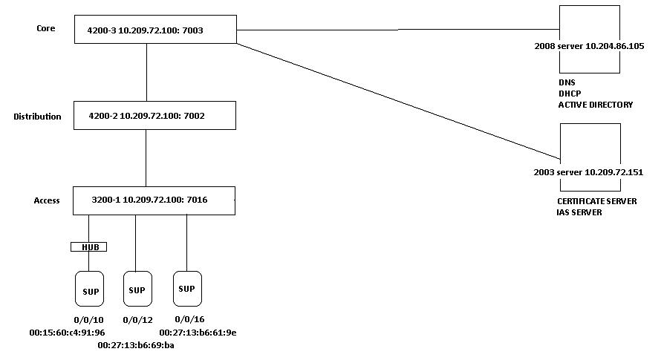
Access Switch:
This switch is configured as authenticator, where all the supplicants are connected.
set protocols dot1x authenticator authentication-profile-name test
set protocols dot1x authenticator interface ge-0/0/10.0 supplicant multiple
set protocols dot1x authenticator interface ge-0/0/10.0 guest-vlan guest
set protocols dot1x authenticator interface ge-0/0/10.0 server-fail vlan-name guest
set protocols dot1x authenticator interface ge-0/0/12.0 supplicant single-secure
set protocols dot1x authenticator interface ge-0/0/12.0 guest-vlan guest
set protocols dot1x authenticator interface ge-0/0/12.0 server-fail vlan-name guest

set access radius-server 10.204.86.89 port 1812
set access radius-server 10.204.86.89 secret "$9$oBZDk5Qnp0I.P0IEcvMaZU"
set access radius-server 10.204.86.89 timeout 30
set access radius-server 10.204.86.89 retry 10
set access profile test authentication-order radius
set access profile test radius authentication-server 10.204.86.89

set vlans data vlan-id 20
set vlans data interface ge-0/0/22.0
set vlans dhcp vlan-id 40
set vlans guest vlan-id 30
set vlans mgmt vlan-id 100
set vlans mgmt l3-interface vlan.100
set interfaces vlan unit 100 family inet address 100.100.100.1/24 (This is the L3 interface used for routing packets to Servers)

Distribution Switch:

This switch is having the L3 interfaces for Data and Guest vlan.
Helper configuration is made on this switch for forwarding the bootp packets to the DHCP server.
OSPF is configured between the Distribution and Core switch and point to point link between them for routing on 0/0/20.

set vlans data vlan-id 20
set vlans data l3-interface vlan.20
set interfaces vlan unit 20 family inet address 10.10.12.1/24
set vlans guest vlan-id 30
set vlans guest l3-interface vlan.30
set interfaces vlan unit 30 family inet address 10.10.13.1/24
set vlans mgmt vlan-id 100
set vlans mgmt l3-interface vlan.100
set interfaces vlan unit 100 family inet address 100.100.100.2/24
set interfaces ge-0/0/20 unit 0 family inet address 9.9.9.1/30
set vlans dhcp vlan-id 40 (This is the vlan which is used for connecting the Servers, L3 for this is in Core Switch)

set forwarding-options helpers bootp interface vlan.20 server 10.204.86.105
set forwarding-options helpers bootp interface vlan.30 server 10.204.86.105.

set protocols ospf area 0.0.0.0 interface vlan.20
set protocols ospf area 0.0.0.0 interface vlan.30
set protocols ospf area 0.0.0.0 interface vlan.100
set protocols ospf area 0.0.0.0 interface ge-0/0/20.0

set routing-options static route 10.204.86.0/24 next-hop 9.9.9.2

Core Switch:

This switch is configured with L3 interface for DHCP vlan.
Point to Point link between Core and Distribution on ge-0/0/20 with OSPF running to route protocols.

set vlans data vlan-id 20
set vlans guest vlan-id 30
set vlans dhcp vlan-id 40
set vlans dhcp vlan-id 40 l3-interface vlan.40
set interfaces vlan unit 40 family inet address 10.204.86.1/24
set interfaces ge-0/0/20 unit 0 family inet address 9.9.9.2/30

set protocols ospf area 0.0.0.0 interface ge-0/0/20
set protocols ospf area 0.0.0.0 interface vlan.40

Configuring Windows IAS Server (Windows 2003 Server)

- Open the IAS Service from Administrative tools and configure Radius Client settings as shown below:

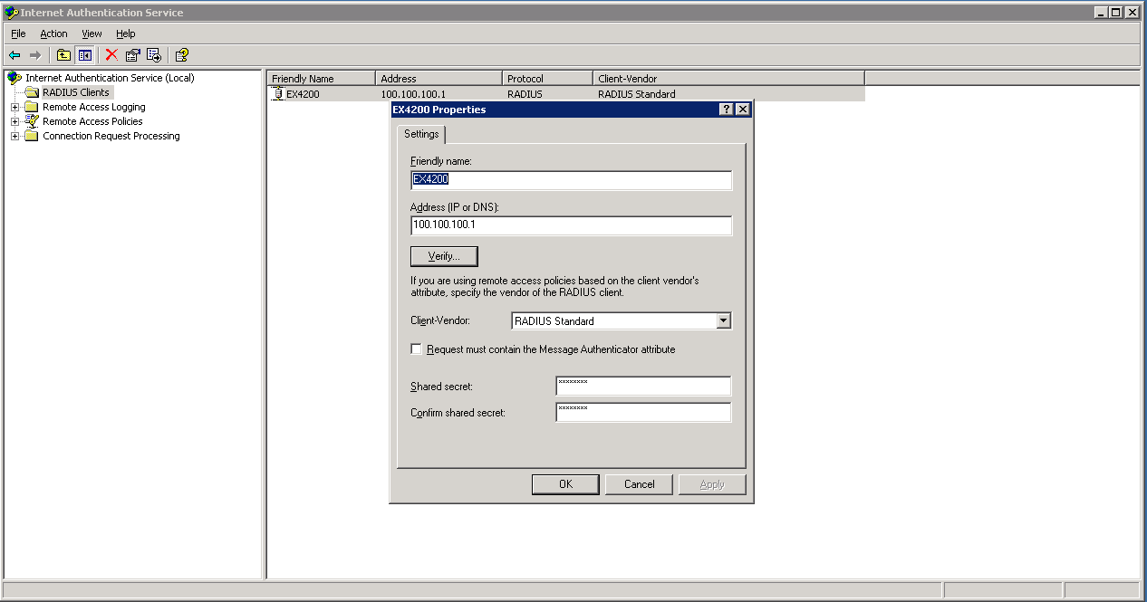

- We have to create a policy to map users and return attributes as shown below:
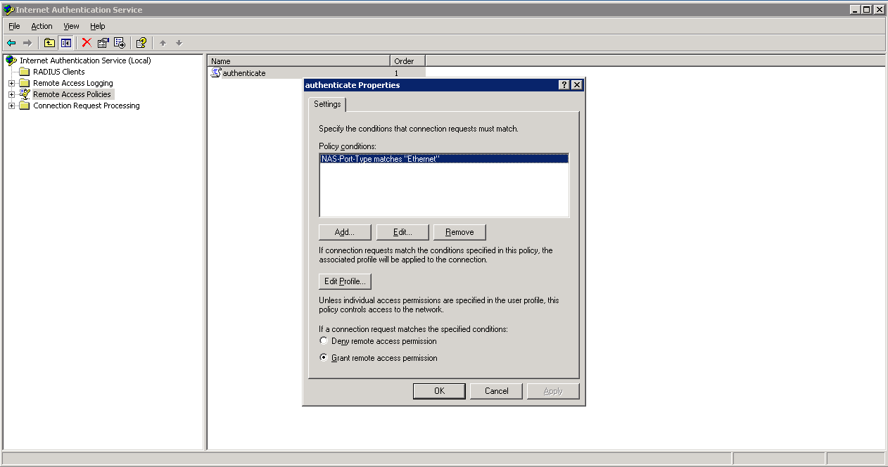

- Click on Edit Profile and go to advanced settings and configure as shown below:
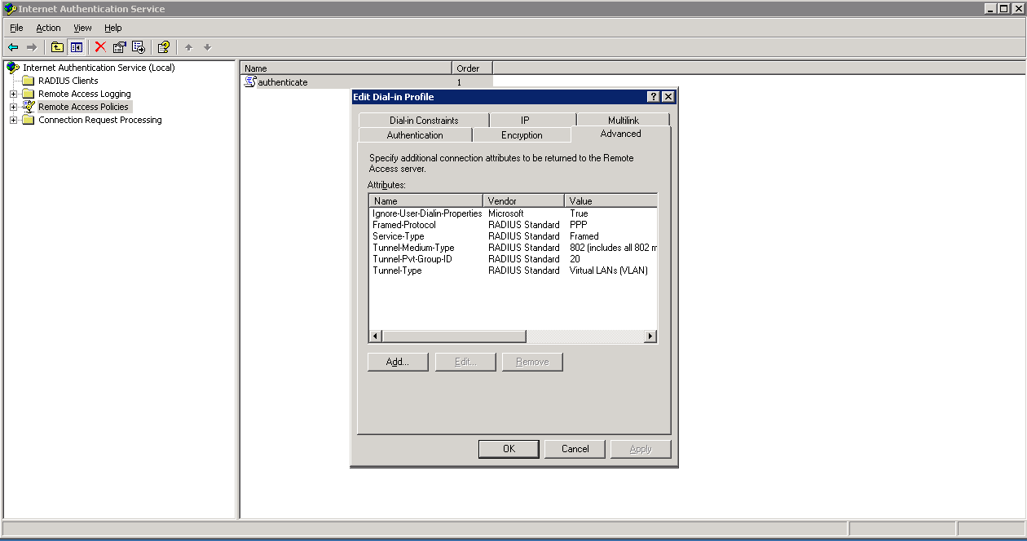

Configuring Certificate Server (Windows 2003 Server)
- First Install the Certificate Server from Add Remove Windows components.
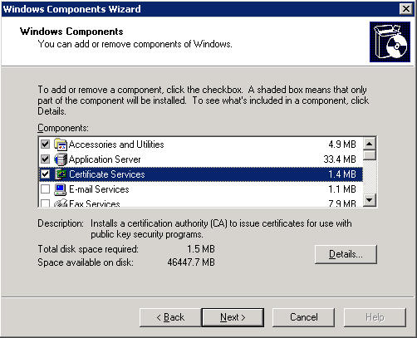
- After installation run the Certification Authority from the Administrative tools.

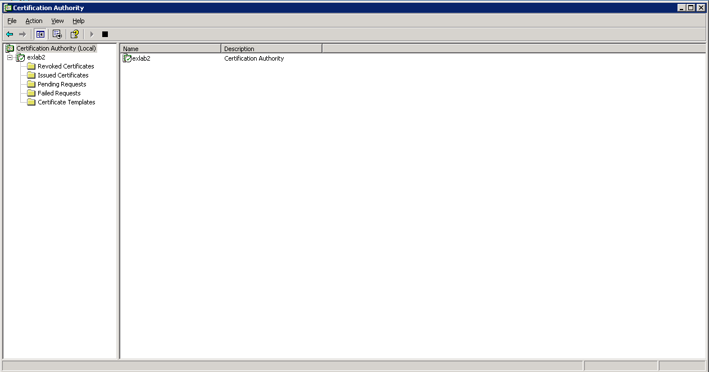

Configuring Active Directory (Windows 2008 Server)
- Open Active Directory from Administrative tools
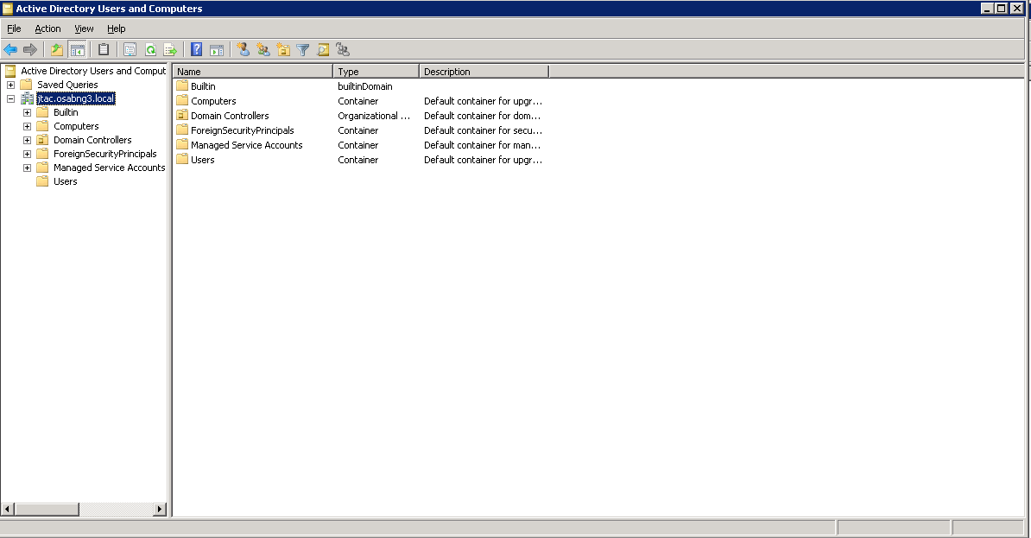
- Add the users which you want to get authenticated through AD / IAS.
Note: We need to create a domain and then add the users under this domain. All the servers will belong to the same domain for instance “jtac.osabng3.local”.
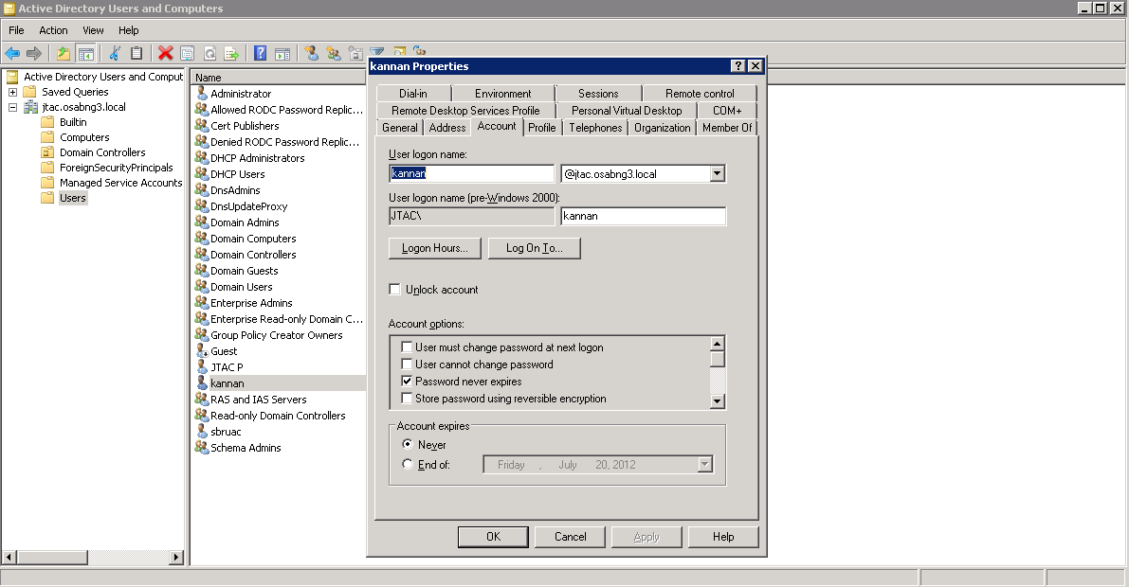

Configuring DNS Service (Windows 2008 Server)
- Run the DNS Service from Administrative Tools for the domain jtac.osabng3.local as shown below:
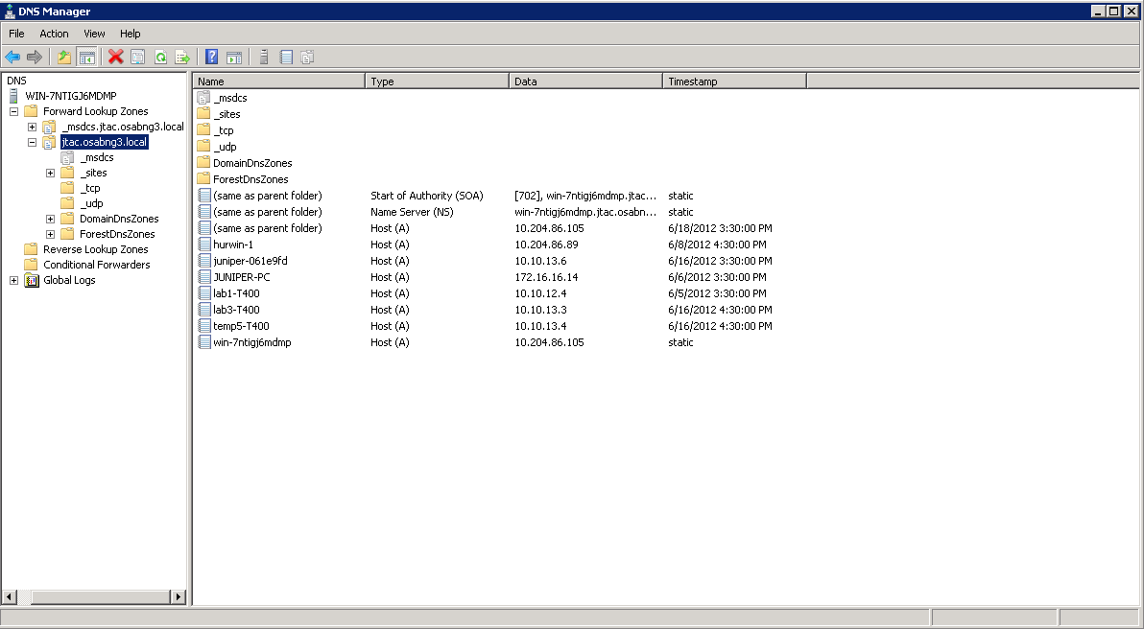
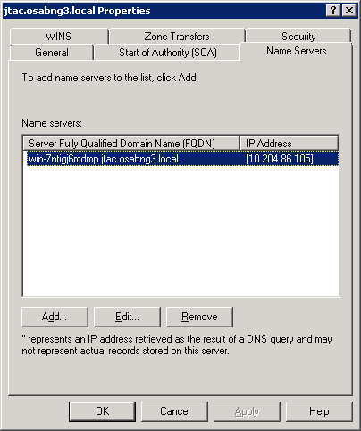

Configuring DHCP Service (Windows 2008 Server)
- Configure the Pools for Data and Guest Vlan as shown below in the DHCP Server configs:
