SSG5 Config (Using MIP to access the second segment 192.168.2.#)

unset key protection enable
set clock timezone 0
set vrouter trust-vr sharable
set vrouter "untrust-vr"
exit
set vrouter "trust-vr"
unset auto-route-export
exit
set service "RDP_custom" protocol tcp src-port 0-65535 dst-port 3389-3389
set alg appleichat enable
unset alg appleichat re-assembly enable
set alg sctp enable
set auth-server "Local" id 0
set auth-server "Local" server-name "Local"
set auth default auth server "Local"
set auth radius accounting port 1646
set admin name "admin"
set admin password "<admin password here>"
set admin auth web timeout 10
set admin auth dial-in timeout 3
set admin auth server "Local"
set admin format dos
set zone "Trust" vrouter "trust-vr"
set zone "Untrust" vrouter "trust-vr"
set zone "DMZ" vrouter "trust-vr"
set zone "VLAN" vrouter "trust-vr"
set zone "Untrust-Tun" vrouter "trust-vr"
set zone "Trust" tcp-rst
set zone "Untrust" block
unset zone "Untrust" tcp-rst
set zone "MGT" block
unset zone "V1-Trust" tcp-rst
unset zone "V1-Untrust" tcp-rst
set zone "DMZ" tcp-rst
unset zone "V1-DMZ" tcp-rst
unset zone "VLAN" tcp-rst
set zone "Untrust" screen tear-drop
set zone "Untrust" screen syn-flood
set zone "Untrust" screen ping-death
set zone "Untrust" screen ip-filter-src
set zone "Untrust" screen land
set zone "V1-Untrust" screen tear-drop
set zone "V1-Untrust" screen syn-flood
set zone "V1-Untrust" screen ping-death
set zone "V1-Untrust" screen ip-filter-src
set zone "V1-Untrust" screen land
set interface "ethernet0/0" zone "Null"
set interface "ethernet0/1" zone "DMZ"
set interface "ethernet0/2" zone "Untrust"
set interface "ethernet0/3" zone "Trust"
set interface "bgroup0" zone "Trust"
set interface bgroup0 port ethernet0/4
set interface bgroup0 port ethernet0/5
set interface bgroup0 port ethernet0/6
unset interface vlan1 ip
set interface ethernet0/2 ip 192.168.1.91/24
set interface ethernet0/2 route
set interface ethernet0/3 ip 192.168.3.1/24
set interface ethernet0/3 nat
set interface bgroup0 ip 192.168.2.1/24
set interface bgroup0 nat
unset interface vlan1 bypass-others-ipsec
unset interface vlan1 bypass-non-ip
set interface ethernet0/2 ip manageable
set interface ethernet0/3 ip manageable
set interface bgroup0 ip manageable
set interface ethernet0/2 manage ping
set interface ethernet0/2 manage ssh
set interface ethernet0/2 manage ssl
set interface ethernet0/2 manage web
unset interface ethernet0/3 manage telnet
unset interface ethernet0/3 manage snmp
unset interface bgroup0 manage telnet
unset interface bgroup0 manage snmp
set interface ethernet0/3 dhcp server service
set interface bgroup0 dhcp server service
set interface ethernet0/3 dhcp server enable
set interface bgroup0 dhcp server enable
set interface ethernet0/3 dhcp server option lease 1440000
set interface ethernet0/3 dhcp server option gateway 192.168.3.1
set interface ethernet0/3 dhcp server option domainname MyDomain
set interface ethernet0/3 dhcp server option dns1 192.168.1.1
set interface bgroup0 dhcp server option lease 1440000
set interface bgroup0 dhcp server option gateway 192.168.2.1
set interface bgroup0 dhcp server option domainname MyDomain
set interface bgroup0 dhcp server option dns1 192.168.1.1
set interface ethernet0/3 dhcp server ip 192.168.3.33 to 192.168.3.44
set interface bgroup0 dhcp server ip 192.168.2.130 to 192.168.2.135
unset interface ethernet0/3 dhcp server config next-server-ip
unset interface bgroup0 dhcp server config next-server-ip
set interface "ethernet0/2" mip 192.168.1.130 host 192.168.2.130 netmask 255.255.255.248 vr "trust-vr"
set interface "serial0/0" modem settings "USR" init "AT&F"
set interface "serial0/0" modem settings "USR" active
set interface "serial0/0" modem speed 115200
set interface "serial0/0" modem retry 3
set interface "serial0/0" modem interval 10
set interface "serial0/0" modem idle-time 10
set flow tcp-mss
unset flow no-tcp-seq-check
set flow tcp-syn-check
unset flow tcp-syn-bit-check
set flow reverse-route clear-text prefer
set flow reverse-route tunnel always
set domain MyDomain
set pki authority default scep mode "auto"
set pki x509 default cert-path partial
set dns host dns1 192.168.1.1
set dns host dns2 0.0.0.0
set dns host dns3 0.0.0.0
set address "Trust" "192.168.3.0/24" 192.168.3.0 255.255.255.0
set ippool "vpnclient" 10.10.1.100 10.10.1.120
set user "<Your_user_name>" uid 2
set user "<Your_user_name>" type xauth
set user "<Your_user_name>" password "<Your_user_name_ password here>"
unset user "<Your_user_name>" type auth
set user "<Your_user_name>" "enable"
set user "User2" uid 3
set user "User2" type xauth
set user "User2" password "<User2_ password here>"
unset user "User2" type auth
set user "User2" "enable"
set user "vpnclient_ph1id" uid 1
set user "vpnclient_ph1id" ike-id fqdn "client.DynName..org" share-limit 25
set user "vpnclient_ph1id" type ike
set user "vpnclient_ph1id" "enable"
set user-group "vpnclient_group" id 1
set user-group "vpnclient_group" user "vpnclient_ph1id"
set crypto-policy
exit
set ike gateway "vpnclient_gateway" dialup "vpnclient_group" Aggr local-id "vpngw.DynName..org" outgoing-interface "ethernet0/2" preshare "<your_Preshare_key_here>" proposal "pre-g2-3des-sha" "pre-g2-3des-md5" "pre-g2-aes128-sha" "pre-g2-aes128-md5"
set ike gateway "vpnclient_gateway" dpd-liveness interval 30
unset ike gateway "vpnclient_gateway" nat-traversal udp-checksum
set ike gateway "vpnclient_gateway" nat-traversal keepalive-frequency 20
set ike gateway "vpnclient_gateway" xauth server "Local"
unset ike gateway "vpnclient_gateway" xauth do-edipi-auth
set ike respond-bad-spi 1
set ike ikev2 ike-sa-soft-lifetime 60
unset ike ikeid-enumeration
unset ike dos-protection
unset ipsec access-session enable
set ipsec access-session maximum 5000
set ipsec access-session upper-threshold 0
set ipsec access-session lower-threshold 0
set ipsec access-session dead-p2-sa-timeout 0
unset ipsec access-session log-error
unset ipsec access-session info-exch-connected
unset ipsec access-session use-error-log
set xauth default ippool "vpnclient"
set xauth default dns1 192.168.1.1
set xauth default dns2 4.2.2.2
set vpn "vpnclient_tunnel" gateway "vpnclient_gateway" replay tunnel idletime 0 proposal "nopfs-esp-3des-sha" "nopfs-esp-3des-md5" "nopfs-esp-aes128-sha" "nopfs-esp-aes128-md5"
set url protocol websense
exit
set policy id 1 from "Trust" to "Untrust" "Any" "Any" "ANY" permit log
set policy id 1
exit
set policy id 3 name "vpnclient_inbound" from "Untrust" to "Trust" "Dial-Up VPN" "Any" "ANY" tunnel vpn "vpnclient_tunnel" id 0x2 log
set policy id 3
exit
set policy id 5 from "Untrust" to "Trust" "Any" "MIP(192.168.1.130/29)" "ANY" permit log
set policy id 5
exit
set policy id 4 from "Untrust" to "Trust" "Any" "Any" "ANY" permit log
set policy id 4
exit
set nsmgmt bulkcli reboot-timeout 60
set ssh version v2
set ssh enable
set config lock timeout 5
unset license-key auto-update
set telnet client enable
set snmp port listen 161
set snmp port trap 162
set snmpv3 local-engine id "01621007003110"
set vrouter "untrust-vr"
exit
set vrouter "trust-vr"
unset add-default-route
set route 0.0.0.0/0 interface ethernet0/2 gateway 192.168.1.1
exit
set vrouter "untrust-vr"
exit
set vrouter "trust-vr"
exit

ShrewSoft client config:

n:version:2
n:network-ike-port:500
n:network-mtu-size:1380
n:client-addr-auto:1
n:network-natt-port:4500
n:network-natt-rate:15
n:network-frag-size:540
n:network-dpd-enable:1
n:client-banner-enable:1
n:network-notify-enable:1
n:client-wins-used:1
n:client-wins-auto:1
n:client-dns-used:1
n:client-dns-auto:1
n:client-splitdns-used:1
n:client-splitdns-auto:1
n:phase1-dhgroup:2
n:phase1-life-secs:86400
n:phase1-life-kbytes:0
n:vendor-chkpt-enable:0
n:phase2-life-secs:3600
n:phase2-life-kbytes:0
n:policy-nailed:1
n:policy-list-auto:1
s:network-host:DynName.dyndns.org
s:client-auto-mode:push
s:client-iface:virtual
s:network-natt-mode:enable
s:network-frag-mode:enable
s:auth-method:mutual-psk-xauth
s:ident-client-type:fqdn
s:ident-server-type:fqdn
s:ident-client-data:client.DynName.org
s:ident-server-data:vpngw.DynName.org
b:auth-mutual-psk:<your_key_Here>
s:phase1-exchange:aggressive
s:phase1-cipher:auto
s:phase1-hash:auto
s:phase2-transform:auto
s:phase2-hmac:auto
s:ipcomp-transform:disabled
n:phase2-pfsgroup:-1
s:policy-level:auto
s:client-saved-username:<Your_user_name>

Network:
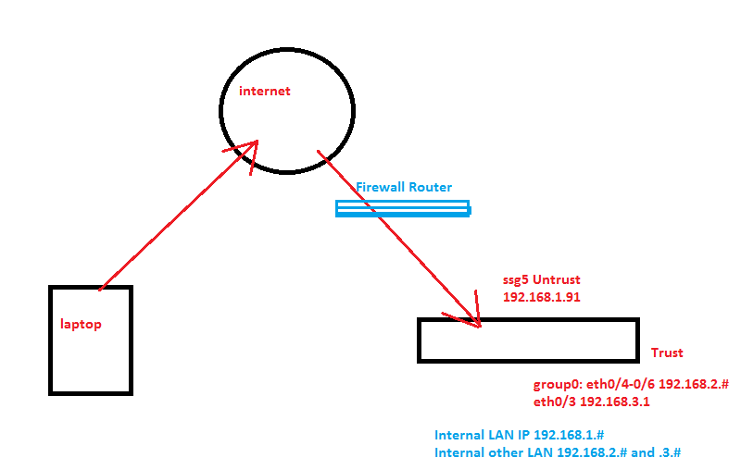

MIP ip’s match from 192.168.1.130-135 to 192.138.2.130-135 automatically

